**FOCUSING ON COMPETENCE AS A STRATEGY TO TEACH ENGLISH FOR SPECIFIC PURPOSES IN CLIL CONTEXTS**

**Author**

**Abstract**

The increasing spread of bilingual programmes in Spanish Universities has had to face multiple worries and uncertainties over the success of Content and Language Integrated Learning (CLIL) and English-medium instruction (EMI) plans (Pavón, 2018).

One of these concerns addresses the question whether content or language should prevail in CLIL teaching. Content teachers worry about giving more importance to language than to the content they need to teach, fearing they will not be able to cope with all the compulsory content during their lectures (Doiz, Lasagabaster & Pavón, 2020). CLIL developers have had to fight against the pessimistic opinions towards CLIL and its implementation in Higher Education (Perez Cañado, 2020).

The present paper aims to meet the need to move towards competence development in CLIL teaching. Approaching language and content teaching through a competence-focused perspective will help us tackle interdisciplinary as well as sustainable development goals through CLIL.

A survey conducted to students of Business English courses within CLIL and Non-CLIL contexts will help us envisage the usefulness of adding non-linguistic skill development to English for Specific Purposes teaching as a way to bridge the gap between language and content.

Keywords:

Content and Language Integrated Learning (CLIL); English-medium instruction (EMI); Internationalisation of Higher Education; English for Specific Purposes (ESP); Business English; Competency-based teaching.

**Introduction**

The emergence of strategic plans fostering the internationalisation of Higher Education (HE) in Spain has revealed there is an increasing motivation for implementing pluri- and bilingual programmes (Ávila-López, Rubio-Cuenca & López-Lechuga, 2021).

However, worries and uncertainties over the success of Content and Language Integrated Learning (CLIL) and English-medium instruction (EMI) programmes (Pavón, 2018) might be thwarting a more substantial increase in the number of university degrees involving the teaching through English as a foreign language (FL) as well as the integration of content and language at university.

In particular, the question whether content or language should predominate in CLIL teaching has been ceaselessly discussed in by Higher Education stakeholders. There is a common concern among content teachers over the inclusion of an external and maybe unnecessary additional goal to their lectures. When it is already difficult to cover all the content planned in the teaching programmes, adding a FL to the learning outcomes can make the teaching planning process even more challenging (Doiz, Lasagabaster & Pavón, 2020). As research has proven the benefits of bilingual teaching in HE, CLIL developers have had to struggle against the pessimistic opinions towards CLIL and its implementation at university (Perez Cañado, 2020).

With the purpose of addressing the need to move towards competence development in CLIL teaching, the present study will explore Competence-focused teaching (or competency-based teaching), which is fostered as a way to engage students in their learning process (Stendera, 2018). Approaching language and content teaching through a competence-focused perspective will help us tackle interdisciplinary as well as sustainable development goals through CLIL.

This objective will positively be accomplished by, firstly, looking into students’ interest in developing certain non-linguistic skills in English for Specific Purposes (ESP) courses. A survey conducted to students of Business English subjects within CLIL and Non-CLIL contexts will help us visualise the effectiveness of adding non-linguistic skill development to ESP teaching as a way to integrate language and content when planning the implementation of bilingual programmes.

**Theory**

Previous studies have identified rejecting attitudes towards CLIL in content university teachers who are invited to take part in the implementation of bilingual programmes (Author, 2020). Dissenting opinions on teaching through English at some point already originated in countries like Sweden the reduction of subjects offered in this language (Airey, 2004). However, the motivation behind such lessening in the number of English-taught subjects was different from the one which nowadays prevails among university content teachers. In the past, possible diglossia and doubts about the quality of content learning (Airey, 2004) were two of the predominant preoccupations of syllabus developers. Research has revealed the advantages in the development of linguistic skills fostered by the implementation of bilingual programmes in a way that neither the mother tongue nor the subject matter is negatively affected (Nieto Moreno de Diezmas, 2017).

Recently, uncertainties and doubts seem to be cast on the specific difficulties in applying CLIL and EMI principles in class. Limitations on what is expected to be an optimal pluri- or bilingual lesson at university may head stakeholders towards rejection. In line with the above, time constraints when planning the syllabus is one of the overriding limitations encountered, as university teachers find it difficult to have enough time to cover all the scheduled content (McDougald, 2014). This tempts them to decline devoting part of their time to any language performance and enhancement, thus rejecting any pluri- or bilingual implementation in which content is not the only teaching goal. Researchers have already warned language is not considered a separate entity in CLIL teaching (Lasagabaster, 2014). In fact, it is thought not to be receiving the required attention in CLIL lessons. University teachers refusing to add a foreign language to their subjects are therefore inclined to foster the prevalence of content versus language in their teaching (Author, 2017). Pavón and Rubio (2010) already emphasised the implications of designing integrated teaching programmes, revealing both content and language teachers ought to contribute to the twofold purpose of CLIL methodology.

Rather than getting stuck in this debate or dichotomy of content versus language focus, university curricula developers need to move forward into a world which is characterised by a growing globalisation that expects our students to demonstrate certain key competencies. In this sense, competency-based teaching in HE has already been applied for years in tertiary language teaching (Pérez Cañado, 2012). Needless to say, the Bologna process meant a significant move toward the competency-based curricula. The Bologna Declaration highlighted two specific aspects regarding bachelor-level degrees, one of them being the necessity to establish clear orientation, profile and learning outcomes for each programme, for the sake of transparency; the second one being the development of transversal skills and competencies required by all active citizens (European Higher Education Area, 2016). A competency-based curriculum should then be understood as one which places emphasis on the needs of the labour market, hence preparing students for precise tasks. As a matter of fact, foreign language competency (and, particularly, English language competency) is one of the basic competencies expected to be acquired by a university graduate in order to enter the intentional market and survive the global competition (Riyandari, 2004).

Competency-based teaching has previously been used as an approach to ESP teaching and, in particular, to Business English (Bratanych & Vyshnevska, 2018) which might require transformations in the teaching process as a way pay full attention to competencies. A competency-based approach (CBA) to ESP will help students meet their needs and aim for a successful professional career (Radjaa, 2012).

The implementation of bilingual programmes combined with the strategies of CLIL and CBA, apart from achieving the goals expected in the strategic plans established by HE institutions, will foster a more competent society might help us nurture sustainability in HE (Wamsler, 2020).

**Method**

In order to gather the data needed for the present study, a survey was designed and conducted at the University of Cadiz (Spain), where the Bachelor’s Degree in Business Management is taught at the Faculty of Business and Economics. That precise Faculty has more than seven years’ experience in offering teaching of content through English as a FL. Nowadays, the students of the aforementioned Degree can choose the possibility to study a Minor in English. It is within this context that the present study was carried out. These business students, once they finish their first year at university, the can choose whether to have some of their subsequent subjects in English or in Spanish. However, it is important to mention that they will not have exactly the same subjects with the same programmes taught in one language or the other, given that their itineraries are different. As established and agreed in the Faculty and according to the intuition’s indications, the approach applied in the Minor in International Business Management is CLIL, as this has been preferred to EMI due to the specific context of the programme.

During these students’ third year they have their ESP subject. The ESP subject within the CLIL Minor is called *English for International Business* (EIB), while the ESP subject in the non-CLIL itinerary is called *English for Business Management* (EBM). With the aim of analysing the key differences between both subjects, we can mention the CEFR (Common European Framework of Reference for Languages) levels of English applied, as in EBM the English level to be acquired at the end of the course is B1, whereas in EIB the English level can go up to B2+ or even C1. It is also important to mention that this Faculty receives one of the most substantial amounts of incoming international students. The interdisciplinarity of its teaching programmes and the offer of subjects taught in English might be considered two of the reasons why this quantity of student mobility is growing year after year. This aspect has an impact on the two Business English subjects examined in our study as it is in the CLIL-context ESP subject (EIB) the one in which we can find a bigger number of international students. Nevertheless, the number of students in EIB is generally smaller than the one in the non-CLIL context ESP subject (EBM), as it can be considered a compulsory subject.

The tool employed to measure students’ willingness to develop specific skills or competencies in their ESP subjects was a survey designed through Google forms. This was the platform selected as students were familiarised with it. It was used in the month of February in 2021. At that time, the whole world was suffering from Covid-19 pandemic, and particularly, from one of its strongest waves, making the University of Cadiz (as many others around Spain) to go online. Lessons would then be held though platforms like Google meet, as is the case of the two subjects of the present study. During the first lesson of both subjects, students were given information about the content, methodology, competencies, evaluation criteria and other aspects of the programme. It is at the beginning of the second lesson that they were given the link to fill in the online survey.

**Results**

The survey was conducted to a total of 112 students participating both in a CLIL and a non-CLIL programme. Of these, 82 students responded, making the sample representative enough to be taken into consideration as it surpasses the 99% expected. It is important to mention that delivering the teaching through videoconference and also circulating the survey in an online format would definitely lower the number of students attending to the lessons and therefore limit the sample of our study.

Subject - *English for International Business (EIB)*

The data gathered in this subject indicates that we had 17 surveyed students out of 32 enrolled students in a CLIL context ESP subject in 2020-2021. 64.7 % were female and 35.3% were male (see Figure 1), most of them 20 to 21 year olds (see Figure 2) studying Business Bachelor Degrees (see Figure 3).

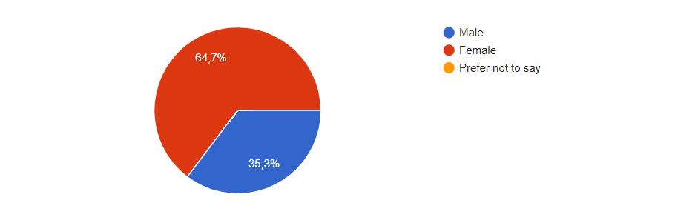

Figure 1 – EIB students’ gender



Figure 2 – EIB students’ age

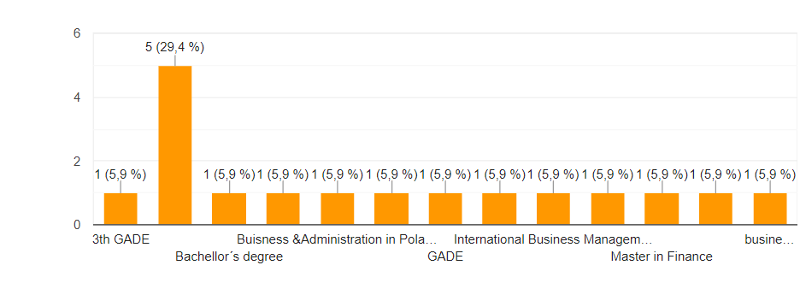

3rd ADE

Figure 3 – EIB students’ fields of study

Regarding their English level, 58.9% were B1 and B2 (see Figure 4)



Figure 4 – EIB students’ level of English

Students were asked the following question: “Are you interested in practicing other non-linguistic aspects in this subject?”. Most of them said their very sufficiently or very interested in practising those skills.

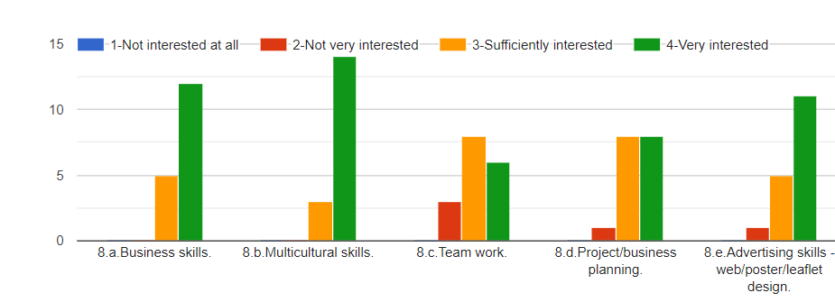

Figure 5 – EIB students’ interest in non-linguistic aspects

Subject - *English for Business Management (EBM)*

In this case, the data gathered in the survey reflects that there were 65 surveyed students out of 80 enrolled students in a non-CLIL context ESP subject in 2020-2021. 47.7 % of them were female and 52.3% were male (see Figure 6), most of them being 20 to 21 year olds (see Figure 7). Most of them were studying Business Bachelor Degrees. As regards their English language level, 57% of them were B1 and B2 (see Figure 8).



Figure 6 – EBM students’ gender

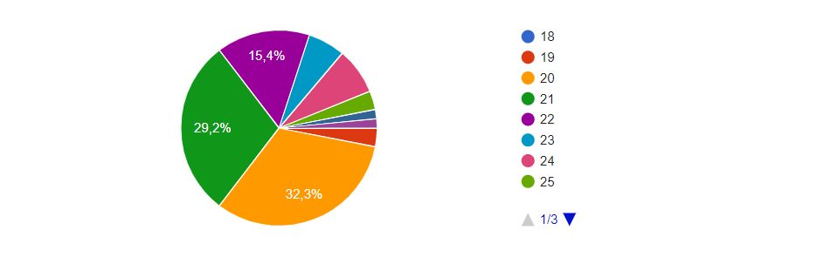

Figure 7 – EBM students’ age

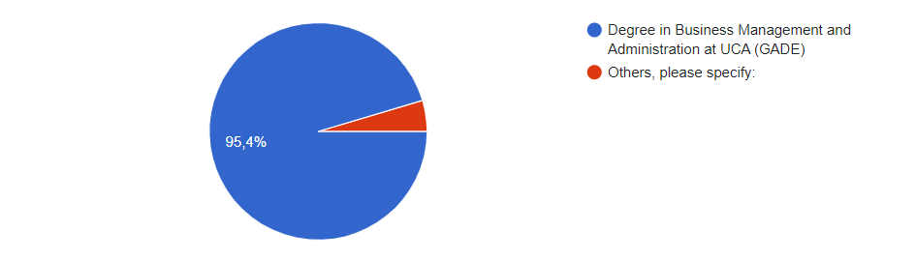

Figure 8 – EBM students’ fields of study



Figure 9 – EBM students’ level of English

As in EIB, respondents were asked whether they were interested in practising other non-linguistic aspects in this subject. Similarly to what happened in EIB, most surveyed EBM students said their very sufficiently or very interested in practising those skills.

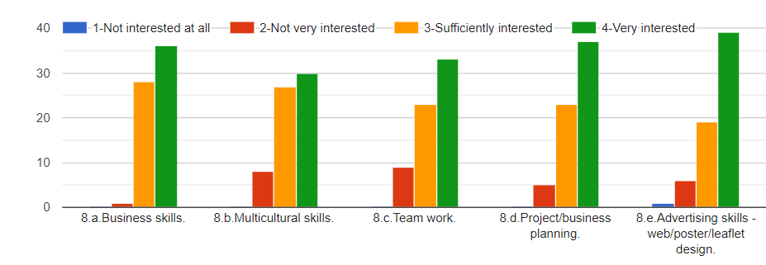

Figure 10 – EBM students’ interest in non-linguistic aspects

**Discussion**

Findings then show that ESP students, both within CLIL and non-CLIL teaching contexts, are willing to develop in their business language subjects not only linguistic skills but other context-related abilities which are connected to the degree they are studying.

Disconnection and classification of skills into categories are often established in syllabuses as a way to organise the teaching-learning process. However, there is also a growing trend in incorporating multidisciplinarity both into research and teaching (particularly in teaching projects, such as Erasmus+ Strategic Alliances for innovation, see Erasmus+ Programme Guide in its version 1, 2022).

*Competencies to be acquired in the degree*

Looking at the official report of the Degree in Business Management and Administration at the University of Cadiz, the basic and general competencies to be acquired are the following ones (Ministry of Education, Culture and Sport, 2018: 6):

Basic competence n. 1: Gaining and understanding knowledge in an area of ​​study that starts from the base of the general secondary education, and it is usually at a level that, while supported by advanced textbooks, also includes some aspects involving knowledge from the forefront of your field of study.

Basic competence n. 2: Knowing how to apply their knowledge to their work or talent in a professional way and possessing the competencies that are often demonstrated through the development and defence of arguments and problem solving mechanisms within their study area.

Basic competence n. 3: Having the ability to gather and interpret relevant data (usually within their area of ​​study) in order to make judgments that include a reflection on relevant issues of a social, scientific or ethical nature.

Basic competence n. 4: Being able to transmit information, ideas, problems and solutions to both specialised and non-specialised audiences.

Basic competence n. 5: Having developed those learning skills necessary to undertake further studies with a high degree of autonomy.

General competence n. 1: Analysis and synthesis.

General competence n. 2: Computer knowledge related to the field of study.

General competence n. 3: Organisational and planning skills.

General competence n. 4: Problem solving.

General competence n. 5: Analysing and searching for information from various sources.

General competence n. 6: Oral and written communication in one's own language.

General competence n. 7: Decision making.

General competence n. 9: Teamwork.

General competence n. 10: Working in interdisciplinary teams.

General competence n. 11: Working in an international context.

General competence n. 12: Personal relationships.

General competence n. 13: Working in diverse and multicultural environments.

General competence n. 14: Critical and self-critical capacity.

General competence n. 15: Ethical commitment at work.

General competence n. 16: Working under pressure.

General competence n. 17: Autonomous learning.

General competence n. 18: Adapting to new situations.

General competence n. 19: Creativity.

General competence n. 20: Leadership.

General competence n. 21: Initiative and entrepreneurial spirit.

General competence n. 22: Motivation for quality.

General competence n. 23: Social responsibility derived from economic and business actions.

Examining the information offered in the aforesaid report regarding the subjects *English for Business Management* (non-CLIL context) and *English for International Business* (CLIL context) (Ministry of Education, Culture and Sport, 2018: 110 y 124 correspondingly), four out of the five basic competencies (BCs) included in the Degree are expected to be developed in both subjects (in particular, CG n. 1 is the only one not included in the subject syllabuses). As regards the general competencies (GCs), nine out of the 23 included in the Degree are expected to be developed in their programmes (namely, GCs n. 6, 9, 10, 11, 12, 13, 14, 15 and 18).

Analysing the competencies in non-linguistic subjects within the same degree the following rubric can be completed (see Figure 11).

|  |  |  |  |  |  |  |  |  |  |  |  |  |  |  |  |  |  |  |  |  |  |  |  |
| --- | --- | --- | --- | --- | --- | --- | --- | --- | --- | --- | --- | --- | --- | --- | --- | --- | --- | --- | --- | --- | --- | --- | --- |
|  | GCs | | | | | | | | | | | | | | | | | | | | | | |
| Course | 1 | 2 | 3 | 4 | 5 | 6 | 7 | 8 | 9 | 10 | 11 | 12 | 13 | 14 | 15 | 16 | 17 | 18 | 19 | 20 | 21 | 22 | 23 |
| EIB |  |  |  |  |  | x |  |  | x | x | x | x | x | x | x |  |  | X |  |  |  |  |  |
| EBM |  |  |  |  |  | x |  |  | x | x | x | x | x | x | x |  |  | X |  |  |  |  |  |
| PM |  |  |  |  |  | x | x |  |  | x | x | x | x | x | x |  |  | x | x | x | x | x | x |
| HRM I | x | x | x | x | x | x | x |  | x |  |  |  |  | x | x | x |  |  |  |  |  |  | x |
| HRM II | x |  | x | x | x | x | x |  | x |  |  |  |  | x | x | x |  |  |  |  |  |  | x |
| IBE | x |  | x | x | x | x | x |  | x |  |  | x |  |  |  |  | x |  |  |  |  |  | x |
| IM | x |  |  | x | x | x |  |  | x |  |  |  |  |  |  |  |  |  |  |  |  |  |  |
| BBM | x |  | x |  | x | x |  |  | x |  |  |  |  | x | x |  | x |  |  |  |  |  | x |
| MM | x | x | x | x | x | x | x |  | x |  |  |  |  | x |  |  | x |  | x | x | x |  | x |
| MS |  | x | x | x |  | x | x |  | x |  |  | x |  | x | x | x |  |  | x |  |  |  | x |

PM: Project Management

HRM I: Human Resource Management 1

HRM II: Human Resource Management 2

IBE: Introduction to Business Economics

IM: Introduction to marketing

BBM: Basics of Business Management

MM: Marketing Management

MS: Managerial Skills

Figure 11 – General competencies of the Business Bachelor’s Degree courses

*Coincidence in competencies to be acquired in different subjects*

As previously highlighted, content university teachers invited to add bilingualism their teaching might demonstrate a negative reaction towards such implementation of CLIL or EMI as a consequence of their feeling they will not be able to cover all the content in a lesson taught (totally or partially) in English. While it might be true that examining the content of the different subjects along the degree one may find it difficult to encounter very clear similarities amongst syllabuses, the results obtained by looking into competencies rather than contents may possibly be different.

As can be seen in Figure 11, some of the GCs seem to be common in many of the subject[1]. GCs 6, 9, 14, 15 and 23 appear to be developed in at least six out of the ten subjects examined. In fact, CGs number 6, which refers to communication in one’s own language, is included in all of them. Taking this into consideration, one may wonder if it is necessary to have one GC developed in all the subjects listed. In case it was, it might convenient to specify the depth that competence development would reach so as to distinguish between the different subjects and to justify this GC development in all of them. If may also be an opportunity for finding common ground among subjects so as to foster well-coordinated bilingual programmes in which syllabuses are designed and planned from the perspective of shared goals. If it were not strictly necessary to have one single GC coexisting in different subjects, it might then be a good chance for CLIL developers to select some of them, concurrently freeing content teachers from the pressure of time constraints.

An example of common competencies which might be incorporated to many business course syllabuses is the case of Sustainable Development Goals, recently fostered so as to facilitate reflection on society’s main challenges.

**Conclusion**

Developing teaching programmes in HE which actually meet the needs of an increasingly globalised society requires designing internationalisation strategies. The implementation of pluri- and/or bilingual programmes at university definitely faces this challenge by promoting FL performance and benefitting from deep content acquisition though an example of internationalisation at home. Nevertheless, in the process of integrating content and language in lectures certain obstacles may occur, such as the discussion on the prevalence of language or content in CLIL teaching. The presence of an additional goal is seen by some content teachers as a threat against the existence of a unique content-related learning outcome. The search for sustainable teaching practices as well as for integrated course design might lead us to find common ground in the programmes of the different linguistic and non-linguistic subjects taking part in the same teaching itinerary. Focusing on competence development might then help CLIL developers to design teaching programmes where multidisciplinary common goals are shared. ESP subjects incorporated into CLIL teaching programmes can offer the syllabus designers an opportunity of coordination that may enrich the students’ learning process.

**References**

Airey, J. (2004). “Can you teach it in English? Aspects of the language choice debate in Swedish higher education”. In R. Wilkinson (ed*.), Integrating content and language. Meeting the challenge of a multilingual education*, 97–108. Maastricht: Maastricht University.

Ávila-López, J.; Rubio-Cuenca, F. & López-Lechuga, R. (2021). “AGCEPESA Project: Designing a Tool to Measure the Quality of Plurilingual Programmes in Higher Education”. In F.D. Rubio-Alcalá and D. Coyle (eds), *Developing and Evaluating Quality Bilingual Practices in Higher Education*. Multilingual matters. 128: 137-162.

Bratanych, O. & Vyshnevska, K. (2018). “Competency-Based Approach to Teaching English for Specific Purposes (ESP) and Business English (BE)”. *Polonia University Scientific Journal*. 27(2):106-115. DOI: 10.23856/2712.

Author, (2017). *Técnicas didácticas y metodológicas para el perfeccionamiento de la gestión del aprendizaje del profesor AICLE en la enseñanza superior*. Doctoral thesis. University of Cadiz.

Author, (2020). “CLIL Teacher Training for Reducing Rejection Towards Bilingual Education at University”. In Sánchez-Pérez, María del Mar (ed), [*Teacher Training for English-Medium Instruction in Higher Education*](https://www.igi-global.com/book/teacher-training-english-medium-instruction/236142)*. Chapter 12*: 257-273. DOI: 10.4018/978-1-7998-2318-6.ch012.

Doiz, A.; Lasagabaster, D. & Pavón, V. (2020). “The integration of language and content in English-medium instruction courses: Lecturers' beliefs and practices”. *Iberica 38*: 151-175.

European Commision (2021). *Erasmus+ Programme Guide*. Version 1, 2022 (24/11/2021).

European Higher Education Area (2016). *Bologna Process, work programme 1999-2001*. International seminar on bachelor level degree. Published: 17/02/2001, last modified: 21/03/2016. Retrieved from: <https://bit.ly/3f6bHSV>.

Lasagabaster, D. (2014). Content versus language teacher: How are CLIL students affected? In Integration of theory and practice in CLIL. Leiden, The Netherlands: Brill Rodopi. <https://doi.org/10.1163/9789401210614_009>

McDougald, J. (2014). “Teachers’ attitudes, perceptions and experiences in CLIL: A look at content and language”. *Colombian Applied Linguistics Journal*, 17(1), 25–41. doi:10.14483/udistrital.jour. calj.2015.1.a0

Ministry of Education, Culture and Sport (2018) *Memoria del título de Graduado en Administración y Dirección de Empresas por la Universidad de Cádiz.*

Nieto Moreno De Diezmas, E. (2017). “Eficacia de los programas bilingües en la adquisición de las destrezas comunicativas en lengua inglesa. Un estudio comparativo”. *XVIII Congreso Internacional de la SEDLL: Visión Histórica y Prospectiva de la Educación Lingüística y Literaria*.

Pavón Vázquez, V. (2018). “La controversia de la educación bilingüe en España”. Tribuna Norteamericana, 26: 20-27.

Pavón Vázquez, V. & Rubio, F. (2010). “Teachers’ Concerns and Uncertainties about the Introduction of CLIL Programmes.” *Porta Linguarum*, vol. 14. 45-58.

Pérez Cañado, M.L. (2012). *Competency-Based Language Teaching in Higher Education****.*** ISBN 10: [9400753853](https://www.iberlibro.com/products/isbn/9789400753853?cm_sp=bdp-_-ISBN10-_-PLP) / ISBN 13: [9789400753853](https://www.iberlibro.com/products/isbn/9789400753853?cm_sp=bdp-_-ISBN13-_-PLP). Editorial: Springer Netherlands, Dordrecht.

Pérez Cañado, M.L. (2020). “Common CLIL (Mis)conceptions: Setting the Record Straight”. *The Manifold Nature of Bilingual Education*. Cambridge Scholars Publishing: 1-30.

Radjaa, D. (2012). *Suggesting a Competency-based Approach to ESP Teaching. A Case Study of Marketing and International Trade Classes at INSIM Institute*. Dissertation.

Riyandari, A. (2004). “Challenges in Implementing Competency-based English Language Teaching at University Level”. *TEFLIN journal*, Vol. 15 (1). 14-26.

Stendera, M. (2018). Teaching through skills-focused feedback”. *Philosophical Pedagogy Workshop*. University of Melbourne

O’Sullivan, N. & Burce, A. (2014). “Teaching and learning in competency-based education”. The Fifth International Conference on e-Learning (e-Learning, 2014). 22-23.

Wamsler, C. (2020). “Education for sustainability: Fostering a more conscious society and transformation towards sustainability”*. International Journal of Sustainability in Higher Education*. ISSN: 1467-6370. 112-130.

1. The chosen courses were selected by fourth-year students who, through a personal interview, were asked about those which could have something in common with the ESP courses they had already studied. They therefore selected eight courses generally related to organisational, managerial and marketing skills somehow connected to the EIB or the EBM course syllabuses.