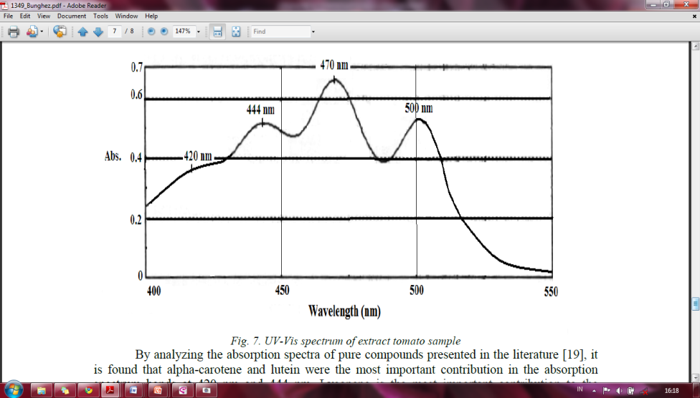

Figure 1.Vis-spectra of tomato sample (Bunghez, 2012)

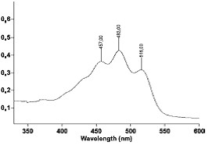

**Abs.**

Figure.2. UV-Vis spectrum of (tomato fruit) lycopene extract in hexane (Djenni et al., 2010)



3

1

2

3

1

2

b

a

Figure 3.Vis-spectra of tomato paste (a) and yogurt-tomato paste (b) scanned at λ 400-700 nm. (1) 446 nm, (2) 472 nm, (3)502 nm

Figure 3. Lycopene content in yogurt-tomato paste