DECLARATION OF ORIGINALITY
AND PLAGIARISM

I hereby certify that I am the sole author of the written work NEW AGE ATHEISM MOVEMENT: A VANISHING MEDIATOR INTO A FUTURISTIC SECULAR SOCIETY and that I have compiled it in my own words and that I have acknowledged all material and sources used in its preparation, whether they are books, articles, reports, lecture notes, and any other kind of document, electronic or personal communication. With my signature, I also certify that the research manuscript has not been previously submitted in any journal and that I have documented all methods, data, and processes truthfully. Also, I have not manipulated any data and I have not copied in part or whole or otherwise plagiarised the work of other persons and/or researchers. Evidently, the similarity index from the digital receipt of Turnitin is 6% while the 3% came from the template of the journal.

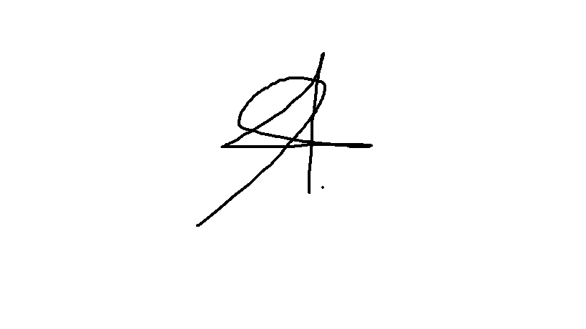

NIÑOVAL F. PACAOL, LPT
Researcher

